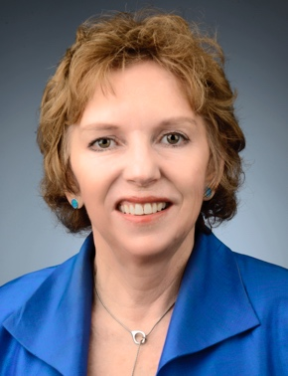

Patricia Conrad DVM, PhD is the Associate Dean for Global Programs at the School of Veterinary Medicine, University of California, Davis and Co-Director of the system-wide (10 campus) UC Global Health Institute. Dr. Conrad is a veterinarian and Distinguished Professor of Parasitology whose research is focused on the transmission of protozoal parasites between wildlife, humans and domestic animals. She received her DVM degree from Colorado State University and PhD from the University of Edinburgh, Scotland. After doing post-doctoral research on the molecular epidemiology of tick-transmitted diseases at the International Laboratory for Research on Animal Diseases in Nairobi, Kenya, she joined the faculty of the School of Veterinary Medicine at the University of California, Davis. Dr. Conrad has published over 225 scientific papers and book chapters in the fields of emerging infectious diseases, parasitology, ecology of fecally-transmitted waterborne pathogens and One Health. She is the recipient of the Carl J. Norden Distinguished Teaching Award, Pfizer Award for Research Excellence, the Oscar W. Schalm and Norman E. Levine Lectureships and an Aldo Leopold Leadership Fellowship. Dr. Conrad was elected to the National Academy of Medicine (formally IOM) in 2011, awarded a Fellowship in the American Academy of Microbiology in 2012 and selected as an American Association of the Advancement of Science Fellow in 2018. In 2017 she received the American Veterinary Medical Association Lifetime Excellence in Research Award for her research and contributions to the veterinary profession, taking a One Health approach that addresses the interconnectedness of humans, animals and the environment. In 2018 she was awarded the UC Davis Chancellor’s Award for International Engagement.

